Travis Austin Wright 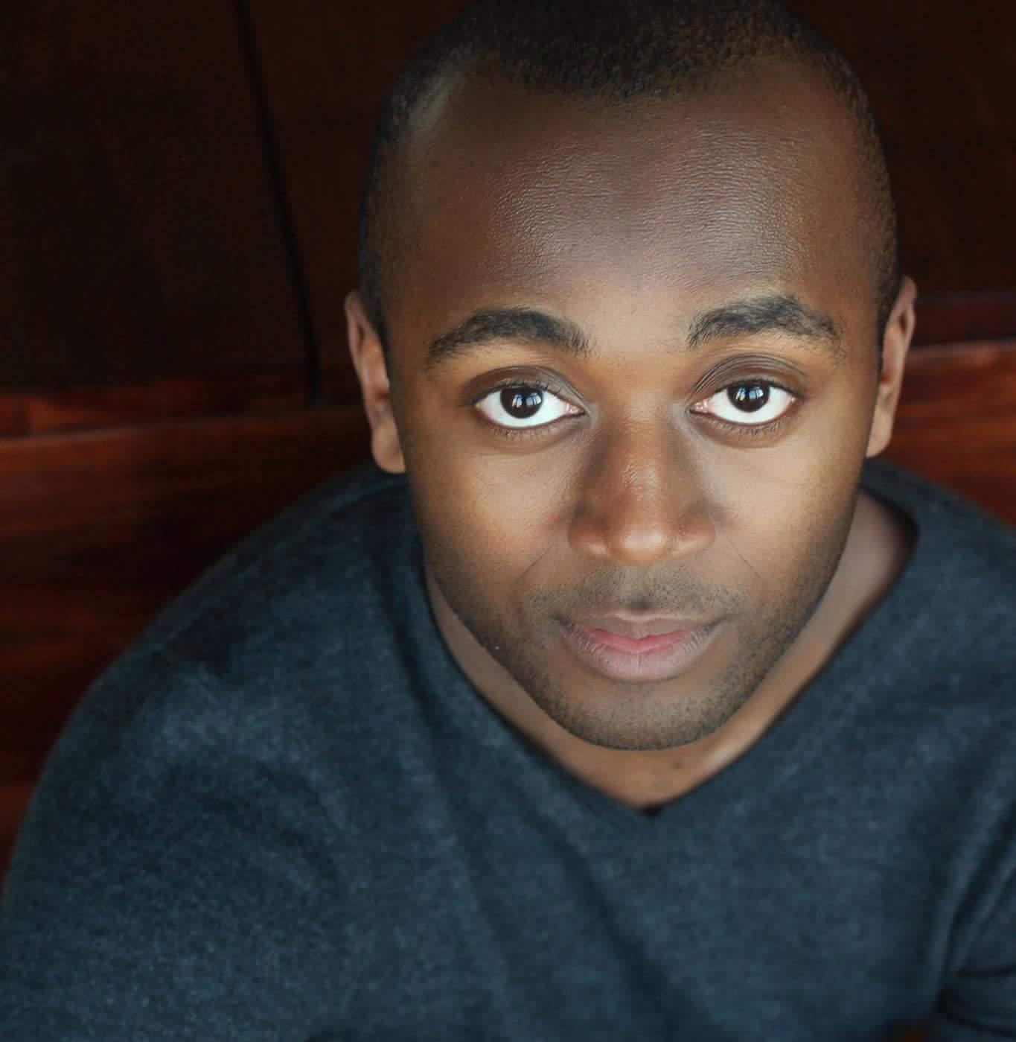
EMC
Height: 5’ 6” Weight: 150lbs
Eyes: Brown Hair: Black TravisWright.Actor@gmail.com
Voice: BariTenor (G2-A5, Belt: Bb4) www.TravisAustinWright.com
STAGE
The Scottsboro Boys | Olen Montgomery,  Dance Captain | Porchlight Music Theatre | Dir. Samuel Roberson
The Bird Girl | Roy | Mercy Street Theatre | Dir. Julia Rohed
Dogfight | Stevens | Boho Theatre | Dir. Peter Marston Sullivan
Madagascar | King Julien U/S, Ensemble U/S | Chicago Shakespeare | Dir. Rachel Rockwell
East of The Sun, West of The Moon | Prince Asbjorn | Coriolis Theatre | Dir. Hannah K. Friedman
The Producers | Ensemble | Mercury Theater | Dir. L. Walter Stearns
In The Heights | Ensemble, Benny U/S (perf), Graffiti Pete U/S (perf), Dance Captain | Porchlight Music Theatre | Dir. Brenda Didier
Rappaccini’s Daughter | Dr. Pietro Baglioni | Pipedreams Studio Theatre | Dir. Joseph Bein
Cabaret | Ensemble | Music Theatre Works | Dir. Stacey Flaster
HMS Pinafore | Ensemble | Music Theatre Works | Dir. Rudy Hogenmiller
Diary of a Worm, Spider & Fly | Ant | Emerald City Theatre | Dir. Jen Ellison
The Play Within | Jimmy | Madkap Productions | Dir. Andrew J. Pond
Enough (staged reading) | Francis Davis | Raven Theatre | Dir, Pam Turlow
A History of Summer | Roy \ Randy | Pride Films & Plays | Dir. David Zak
A Midsummer Night’s Dream | Moth | Millikin University | Dir. Alex Miller
The Portrait of Dorian Gray | Mr. Isaac / Bo’sun | Millikin University | Dir. Joseph Bein
FILM
Film Service | Gordon Miller | Harold Ramis Film School | Dir. Jil Ross
The Hoboet | Ted: The Hobo | Millikin University | Dir. Julia Savia
The Industry Exposed | Male Judge | Industry Productions | Dir. Nisey Rashad
A Dead End Job | Nick | Millikin University | Dir. Charlie G. Huth
EDUCATION/TRAINING
Profiles Theatre
Advanced Scene Study Intensive: Darrell W. Cox, Rick Snyder
Second City Training Center:
Music Conservatory: Michael Girts, Kate Cohen, Aaron Graham, Rachel Mason, Jeff Bouthiette, Matt Van Colten
Improvisation for Actors Program: Michael Gellman
Acting Studio Chicago:
On Camera: Chris Agos
Millikin University:
BA in Music, BA in Theatre, Dance Minor:
___________________________________________________________________________________________________________________________________________Special Skills/Interests
Reads music, Basic Piano, Improvisation, Dance: (Tap, Modern, Jazz, Ballet, HipHop) Gymnastics: (Cartwheels, Roundoffs, Tumbles, Barrel Turns, Handbalancing), Conversational Spanish, Songwriting

